- Hasil
- Uji validitas
Uji validitas pada penelitian ini dilakukan dengan analisis factor dengan menggunakan alat bantu SPSS, digunakan untuk mengetahui apakah instrument layak untuk digunakan dalam penelitian. Uji validitas dilakukan terhadap 30 orang responden yang memenuhi kriteria yang telah ditentukan. Pernyataan dinyatakan valid apabila rhitung > r table, adapun uji validitas dapat dilihat pada table berikut:
Variabel | Item | r tabel | r hitung | keterangan
Persepsi Mahasiswa | X1 | 0,361 | 0,802 | valid
Persepsi Mahasiswa | X2 | 0,361 | 0,754 | valid
Persepsi Mahasiswa | X3 | 0,361 | 0,809 | valid
Persepsi Mahasiswa | X4 | 0,361 | 0,796 | valid
Persepsi Mahasiswa | X5 | 0,361 | 0,861 | valid
Persepsi Mahasiswa | X6 | 0,361 | 0,824 | valid
Persepsi Mahasiswa | X7 | 0,361 | 0,793 | valid
Persepsi Mahasiswa | X8 | 0,361 | 0,861 | valid
Persepsi Mahasiswa | X9 | 0,361 | 0,641 | valid
Persepsi Mahasiswa | X10 | 0,361 | 0,85 | valid
Persepsi Mahasiswa | X11 | 0,361 | 0,898 | valid
Persepsi Mahasiswa | X12 | 0,361 | 0,911 | valid
Persepsi Mahasiswa | X13 | 0,361 | 0,83 | valid
Persepsi Mahasiswa | X14 | 0,361 | 0,782 | valid
Persepsi Mahasiswa | X15 | 0,361 | 0,836 | valid
Persepsi Mahasiswa | X16 | 0,361 | 0,836 | valid
Persepsi Mahasiswa | X17 | 0,361 | 0,911 | valid
Pelaksanaan PPG dalam meningkatan kompetensi merancang media pembelajaran | Y1 | 0,361 | 0,44 | valid
 | Y2 | 0,361 | 0,59 | valid
 | Y3 | 0,361 | 0,784 | valid
 | Y4 | 0,361 | 0,712 | valid
 | Y5 | 0,361 | 0,498 | valid
 | Y6 | 0,361 | 0,442 | valid
 | Y7 | 0,361 | 0,575 | valid
 | Y8 | 0,361 | 0,539 | valid
 | Y9 | 0,361 | 0,704 | valid
 | Y10 | 0,361 | 0,672 | valid
 | Y11 | 0,361 | 0,593 | valid
 | Y12 | 0,361 | 0,595 | valid
 | Y13 | 0,361 | 0,645 | valid
 | Y14 | 0,361 | 0,733 | valid
 | Y15 | 0,361 | 0,685 | valid
 | Y16 | 0,361 | 0,493 | valid
 | Y17 | 0,361 | 0,564 | valid
 | Y18 | 0,361 | 0,66 | Valid
 | Y19 | 0,361 | 0,664 | valid
 | Y20 | 0,361 | 0,604 | valid
 | Y21 | 0,361 | 0,59 | valid

Untuk variable persepsi mahasiswa dari 17 item pernyataan menunjukkan hasil valid. Berarti semua item dalam variable persepsi mahasiswa dapat digunakan dalam penelitian. Sedangkan untuk varibel Peningkatan kompetensi merancang media pembelajaran dari 21 item pernyataan semua item menunjukkan hasil valid. Jadi dalam penelitian ini 38 item dinyatakan valid dan dapat digunakan dalam hasil penelitian.
- Uji Realibitas
Variabel | Item | Alfacronbach | keterangan
Persepsi Mahasiswa | X | 0.965 | Reliabel
Peningkatan kompetensi merancang media pembelajaran | Y | 0.915 | Reliabel
Intinya, kedua variable bias digunakan karna lebi dari 0,5
- Analisis Kualitatif
- Gambaran umum responden
Sampel merupakan mahasiswa peserta program PPG tahap 1 sampai tahap 5 di mata pelajaran PAUD di FKIP UHAMKA tahun 2019. Total sampel sebanyak 65 orang dan seluruhnya berjeis kelamin perempuan.

- Distribusi frekuensi jawaban responden
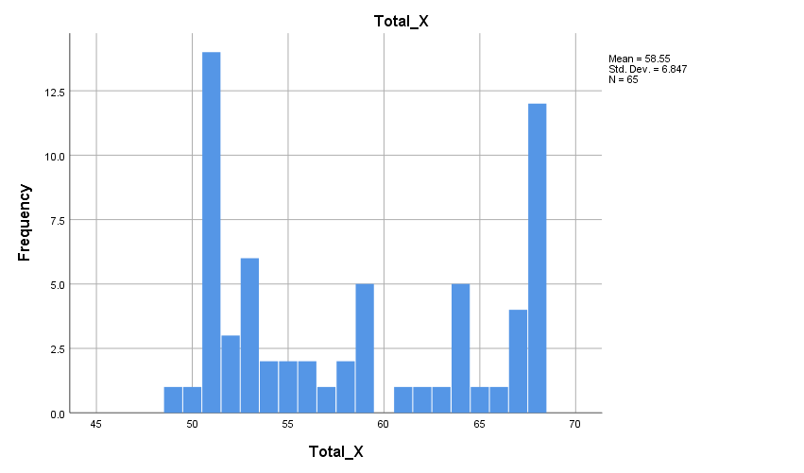

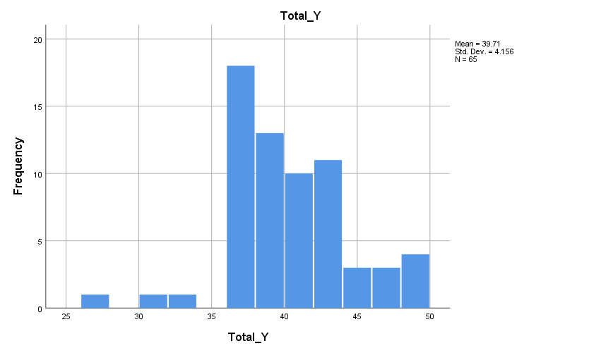

- Analisis bivariate
Correlations

 |  | Persepsi Mahasiswa | Peningkatan kemampuan merancang media pembelajaran
Persepsi Mahasiswa | Pearson Correlation | 1 | .747**
Persepsi Mahasiswa | Sig. (2-tailed) |  | .000
Persepsi Mahasiswa | N | 65 | 65
Peningkatan kemampuan merancang media pembelajaran | Pearson Correlation | .747** | 1
Peningkatan kemampuan merancang media pembelajaran | Sig. (2-tailed) | .000
Peningkatan kemampuan merancang media pembelajaran | N | 65 | 65
**. Correlation is significant at the 0.01 level (2-tailed).

Dari tabel diatas menunjukkan bahwa nilai signifikansi sebesar 0,000 menunjukkan adanya korelasi hubungan antara variabel X dan Y jadi terdapat hubungan antara persepsi mahasiswa pada pelaksanaan PPG terhadap pengembangan media pemebelajaran PAUD. nilai korelasi pearson sebesar 0,747 menunjukkan hubungan yang kuat antara variabel persepsi mahasiswa terhadap pelaksanaan PPG dalam merancang media pembelajaran jadi diartikan bahwa persepsi mahasiswa memiliki persepsi yang kuat terhadap pelaksanaan PPG dalam kemampuan merancang media pembelajaran.
- Uji regresi

Model Summary
Model | R | R Square | Adjusted R Square | Std. Error of the Estimate
1 | .747ª | .557 | .550 | 2.78704
a. Predictors: (Constant), Persepsi Mahasiswa

Table diatas menjelaskan besarnya nilai korelasi/hubungan (R) yaitu sebesar 0,747 dan dijelaskan besarnya besarnya prosentase pengaruh variable bebas terhadap variable terikat. Yang disebut dengan koefisien determinasi 0,557 yang artinya pengaruh variable bebas terhadap variable terikat sebesar 55,7% sisanya dipengaruhi oleh variable lain yang tidak dijelaskan dalam penelitian ini.

ANOVAª
Model |  | Sum of Squares | df | Mean Square | F | Sig.
1 | Regression | 2088.466 | 1 | 2088.466 | 87.265 | .000^{b}
1 | Residual | 1507.749 | 63 | 23.933
1 | Total | 3596.215 | 64
a. Dependent Variable: Y
b. Predictors: (Constant), X
Pada tabel ini menjelaskan tentang adanya pengaruh nyata atau signifikan pada variabel X terhadap variabel Y berdasarkan hasil F hitung=87,265 dengan tingkat signifikansi 0,05 maka model regresi dapat dipakai untuk memprediksi variabel partisipasi.

Coefficientsª
Model |  | Unstandardized Coefficients |  | Standardized Coefficients | t | Sig.
 |  | B | Std. Error | Beta | t | Sig.
1 | (Constant) | 13.173 | 2.999 |  | 4.392 | .000
1 | Persepsi Mahasiswa | .453 | .051 | .747 | 8.906 | .000
a. Dependent Variable: Peningkatan kemampuan merancang media pembelajaran

FREQUENCIES VARIABLES=X1 X2 X3 X4 X5 X6 X7 X8 X9 X10 X11 X12 X13 X14 X15 X16 X17 Y1 Y2 Y3 Y4 Y5 Y6
Y7 Y8 Y9 Y10 Y11 Y12
/HISTOGRAM NORMAL
/ORDER=ANALYSIS.

Frequencies

Notes
Output Created |  | 10-APR-2020 17:47:24
Comments
Input | Active Dataset | DataSet0
Input | Filter | <none>
Input | Weight | <none>
Input | Split File | <none>
Input | N of Rows in Working Data File | 65
Missing Value Handling | Definition of Missing | User-defined missing values are treated as missing.
Missing Value Handling | Cases Used | Statistics are based on all cases with valid data.
Syntax |  | FREQUENCIES VARIABLES=X1 X2 X3 X4 X5 X6 X7 X8 X9 X10 X11 X12 X13 X14 X15 X16 X17 Y1 Y2 Y3 Y4 Y5 Y6  Y7 Y8 Y9 Y10 Y11 Y12  /HISTOGRAM NORMAL  /ORDER=ANALYSIS.
Resources | Processor Time | 00:00:15,48
Resources | Elapsed Time | 00:00:19,78

[DataSet0]

Frequency Table

X1
 |  | Frequency | Percent | Valid Percent | Cumulative Percent
Valid | S | 32 | 49.2 | 49.2 | 49.2
Valid | SS | 33 | 50.8 | 50.8 | 100.0
Valid | Total | 65 | 100.0 | 100.0

X2
 |  | Frequency | Percent | Valid Percent | Cumulative Percent
Valid | TS | 1 | 1.5 | 1.5 | 1.5
Valid | S | 33 | 50.8 | 50.8 | 52.3
Valid | SS | 31 | 47.7 | 47.7 | 100.0
Valid | Total | 65 | 100.0 | 100.0

X3
 |  | Frequency | Percent | Valid Percent | Cumulative Percent
Valid | S | 25 | 38.5 | 38.5 | 38.5
Valid | SS | 40 | 61.5 | 61.5 | 100.0
Valid | Total | 65 | 100.0 | 100.0

X4
 |  | Frequency | Percent | Valid Percent | Cumulative Percent
Valid | S | 35 | 53.8 | 53.8 | 53.8
Valid | SS | 30 | 46.2 | 46.2 | 100.0
Valid | Total | 65 | 100.0 | 100.0

X5
 |  | Frequency | Percent | Valid Percent | Cumulative Percent
Valid | S | 34 | 52.3 | 52.3 | 52.3
Valid | SS | 31 | 47.7 | 47.7 | 100.0
Valid | Total | 65 | 100.0 | 100.0

X6
 |  | Frequency | Percent | Valid Percent | Cumulative Percent
Valid | S | 33 | 50.8 | 50.8 | 50.8
Valid | SS | 32 | 49.2 | 49.2 | 100.0
Valid | Total | 65 | 100.0 | 100.0

X7
 |  | Frequency | Percent | Valid Percent | Cumulative Percent
Valid | S | 34 | 52.3 | 52.3 | 52.3
Valid | SS | 31 | 47.7 | 47.7 | 100.0
Valid | Total | 65 | 100.0 | 100.0

X8
 |  | Frequency | Percent | Valid Percent | Cumulative Percent
Valid | TS | 1 | 1.5 | 1.5 | 1.5
Valid | S | 34 | 52.3 | 52.3 | 53.8
Valid | SS | 30 | 46.2 | 46.2 | 100.0
Valid | Total | 65 | 100.0 | 100.0

X9
 |  | Frequency | Percent
Missing | System | 65 | 100.0

X10
 |  | Frequency | Percent
Missing | System | 65 | 100.0

X11
 |  | Frequency | Percent
Missing | System | 65 | 100.0

X12
 |  | Frequency | Percent
Missing | System | 65 | 100.0

X13
 |  | Frequency | Percent
Missing | System | 65 | 100.0

X14
 |  | Frequency | Percent
Missing | System | 65 | 100.0

X15
 |  | Frequency | Percent
Missing | System | 65 | 100.0

X16
 |  | Frequency | Percent
Missing | System | 65 | 100.0

X17
 |  | Frequency | Percent
Missing | System | 65 | 100.0

Y1
 |  | Frequency | Percent | Valid Percent | Cumulative Percent
Valid | S | 31 | 47.7 | 47.7 | 47.7
Valid | SS | 34 | 52.3 | 52.3 | 100.0
Valid | Total | 65 | 100.0 | 100.0

Y2
 |  | Frequency | Percent | Valid Percent | Cumulative Percent
Valid | TS | 2 | 3.1 | 3.1 | 3.1
Valid | S | 39 | 60.0 | 60.0 | 63.1
Valid | SS | 24 | 36.9 | 36.9 | 100.0
Valid | Total | 65 | 100.0 | 100.0

Y3
 |  | Frequency | Percent | Valid Percent | Cumulative Percent
Valid | TSS | 1 | 1.5 | 1.5 | 1.5
Valid | TS | 1 | 1.5 | 1.5 | 3.1
Valid | S | 48 | 73.8 | 73.8 | 76.9
Valid | SS | 15 | 23.1 | 23.1 | 100.0
Valid | Total | 65 | 100.0 | 100.0

Y4
 |  | Frequency | Percent | Valid Percent | Cumulative Percent
Valid | TS | 4 | 6.2 | 6.2 | 6.2
Valid | S | 35 | 53.8 | 53.8 | 60.0
Valid | SS | 26 | 40.0 | 40.0 | 100.0
Valid | Total | 65 | 100.0 | 100.0

Y5
 |  | Frequency | Percent | Valid Percent | Cumulative Percent
Valid | TS | 2 | 3.1 | 3.1 | 3.1
Valid | S | 48 | 73.8 | 73.8 | 76.9
Valid | SS | 15 | 23.1 | 23.1 | 100.0
Valid | Total | 65 | 100.0 | 100.0

Y6
 |  | Frequency | Percent | Valid Percent | Cumulative Percent
Valid | TSS | 1 | 1.5 | 1.5 | 1.5
Valid | TS | 1 | 1.5 | 1.5 | 3.1
Valid | S | 44 | 67.7 | 67.7 | 70.8
Valid | SS | 19 | 29.2 | 29.2 | 100.0
Valid | Total | 65 | 100.0 | 100.0

Y7
 |  | Frequency | Percent | Valid Percent | Cumulative Percent
Valid | TS | 1 | 1.5 | 1.5 | 1.5
Valid | S | 26 | 40.0 | 40.0 | 41.5
Valid | SS | 38 | 58.5 | 58.5 | 100.0
Valid | Total | 65 | 100.0 | 100.0

Y8
 |  | Frequency | Percent | Valid Percent | Cumulative Percent
Valid | S | 42 | 64.6 | 64.6 | 64.6
Valid | SS | 23 | 35.4 | 35.4 | 100.0
Valid | Total | 65 | 100.0 | 100.0

Y9
 |  | Frequency | Percent | Valid Percent | Cumulative Percent
Valid | TS | 1 | 1.5 | 1.5 | 1.5
Valid | S | 42 | 64.6 | 64.6 | 66.2
Valid | SS | 22 | 33.8 | 33.8 | 100.0
Valid | Total | 65 | 100.0 | 100.0

Y10
 |  | Frequency | Percent | Valid Percent | Cumulative Percent
Valid | TS | 2 | 3.1 | 3.1 | 3.1
Valid | S | 44 | 67.7 | 67.7 | 70.8
Valid | SS | 19 | 29.2 | 29.2 | 100.0
Valid | Total | 65 | 100.0 | 100.0

Y11
 |  | Frequency | Percent | Valid Percent | Cumulative Percent
Valid | TSS | 1 | 1.5 | 1.5 | 1.5
Valid | S | 51 | 78.5 | 78.5 | 80.0
Valid | SS | 13 | 20.0 | 20.0 | 100.0
Valid | Total | 65 | 100.0 | 100.0

Y12
 |  | Frequency | Percent | Valid Percent | Cumulative Percent
Valid | TS | 3 | 4.6 | 4.6 | 4.6
Valid | S | 46 | 70.8 | 70.8 | 75.4
Valid | SS | 16 | 24.6 | 24.6 | 100.0
Valid | Total | 65 | 100.0 | 100.0

Histogram

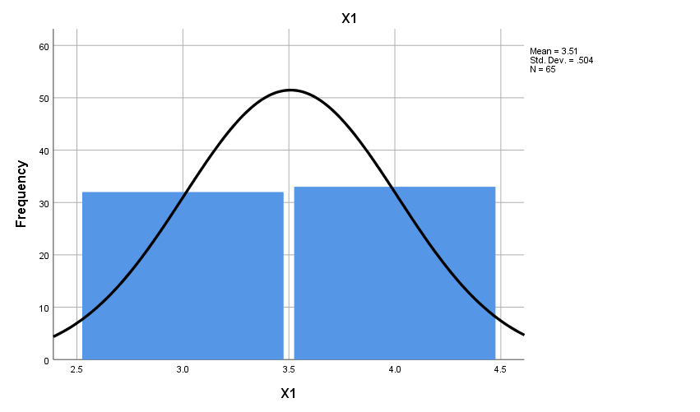

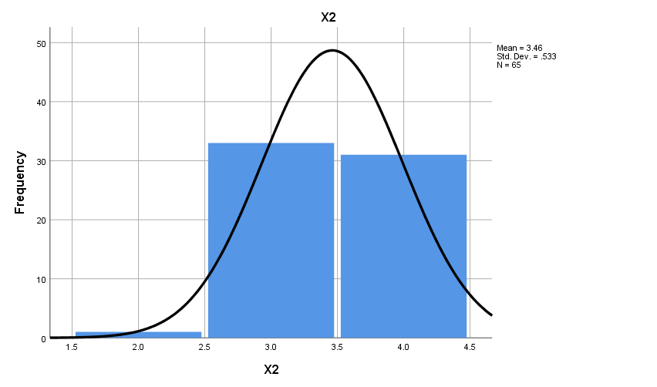

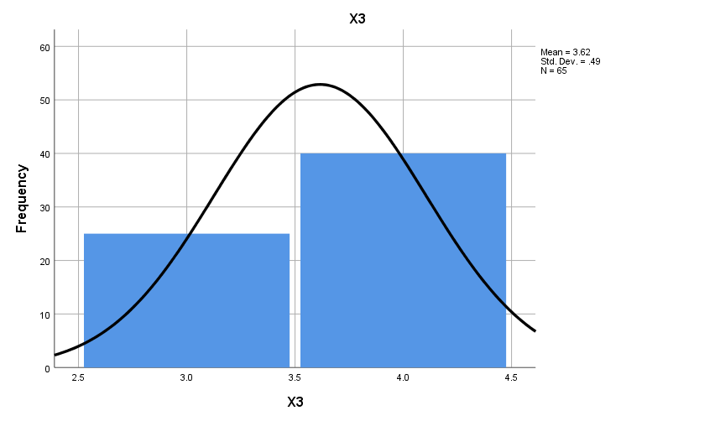

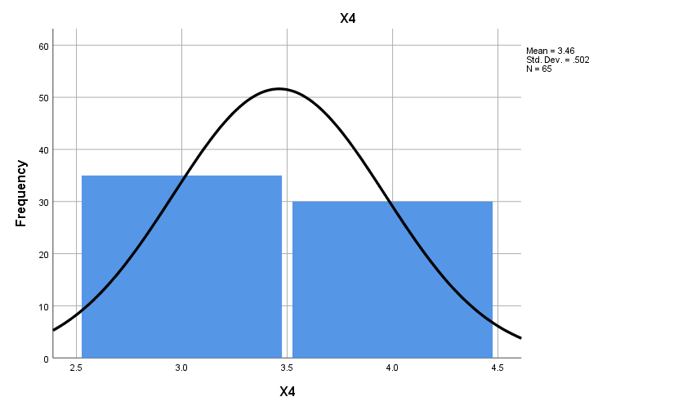

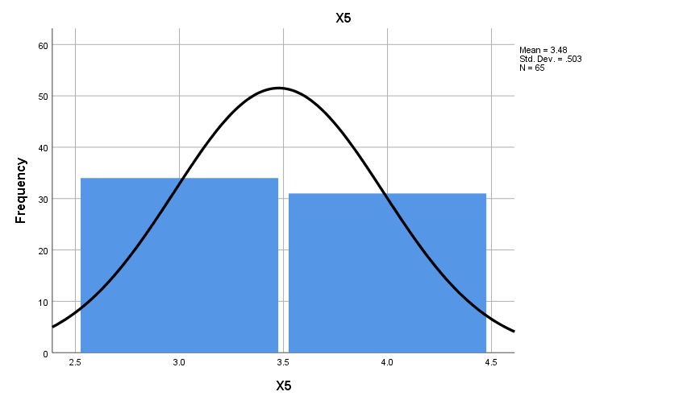

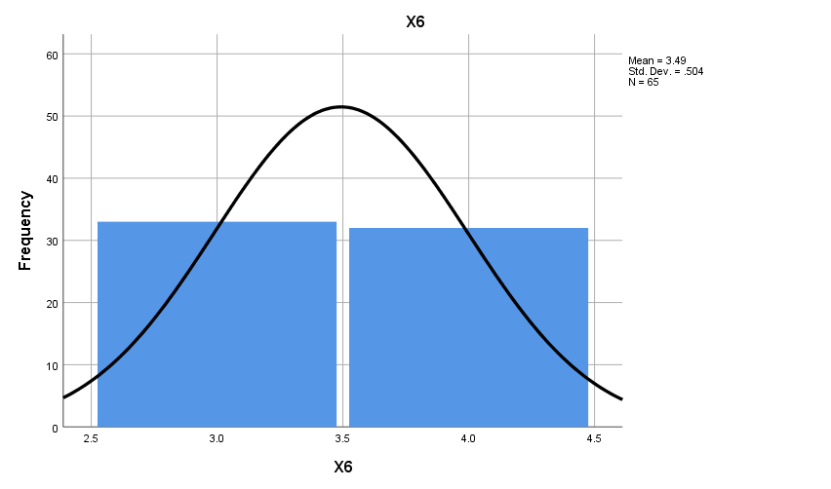

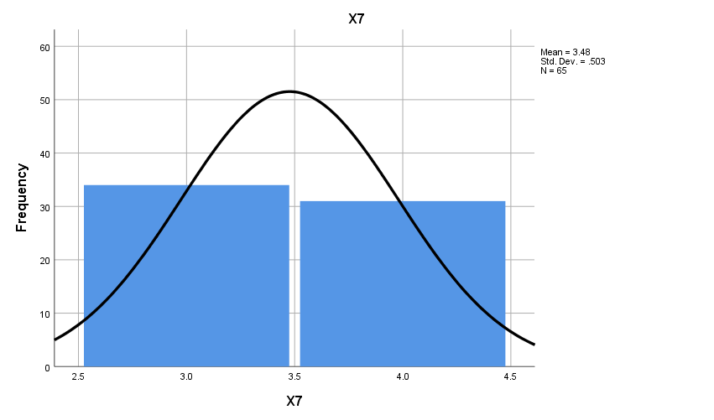

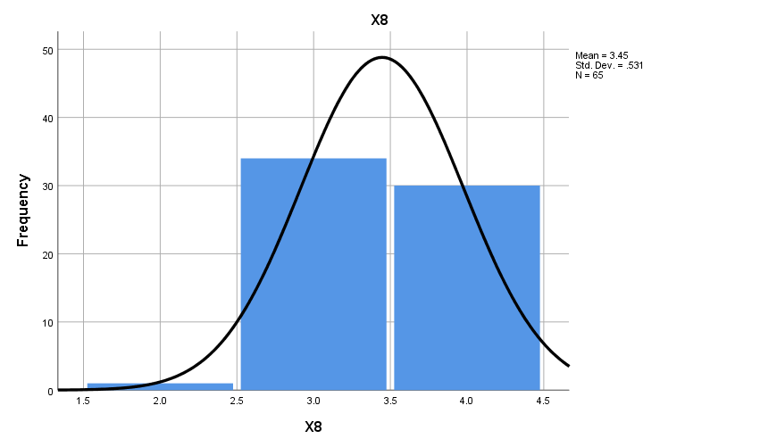

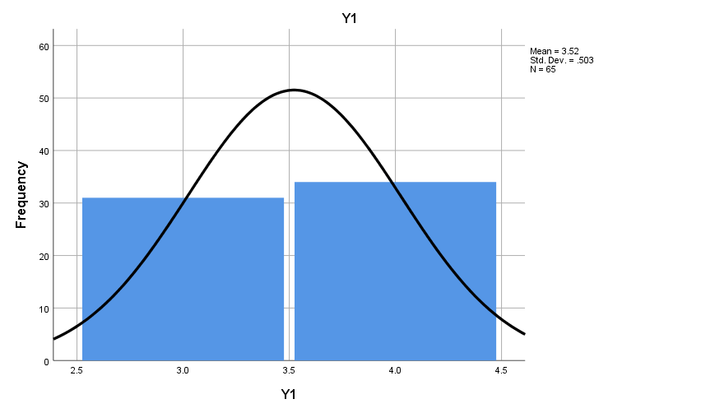

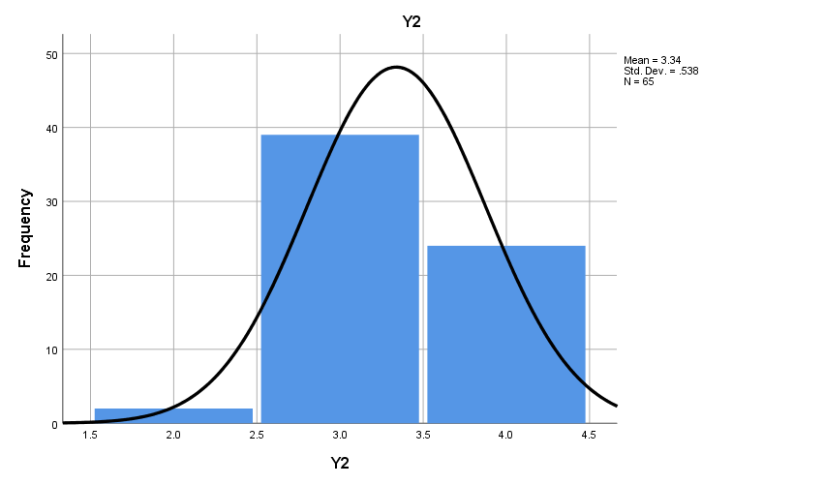

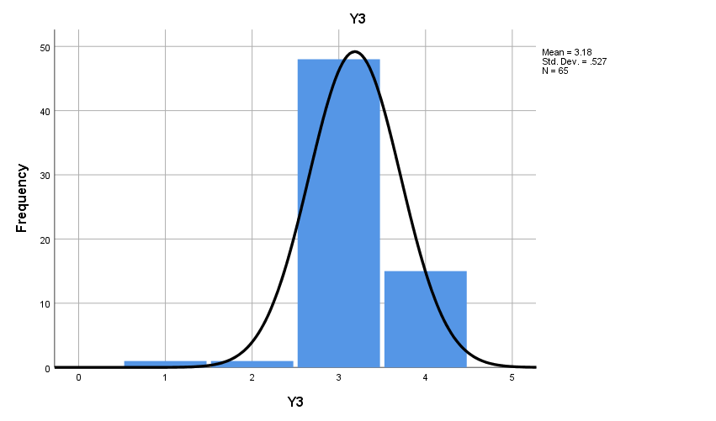

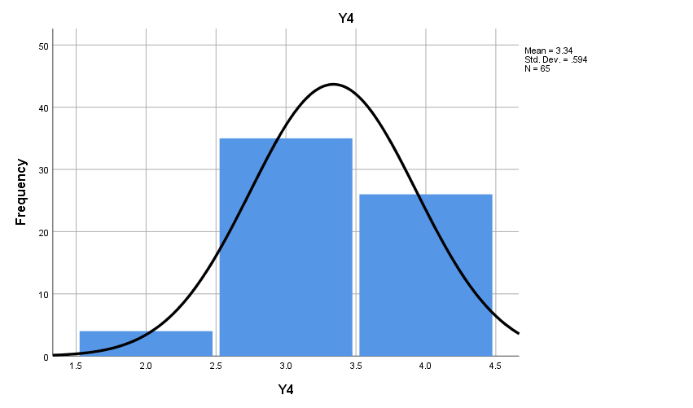

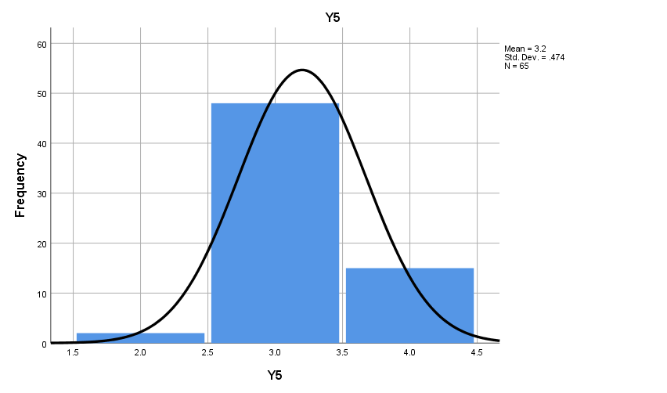

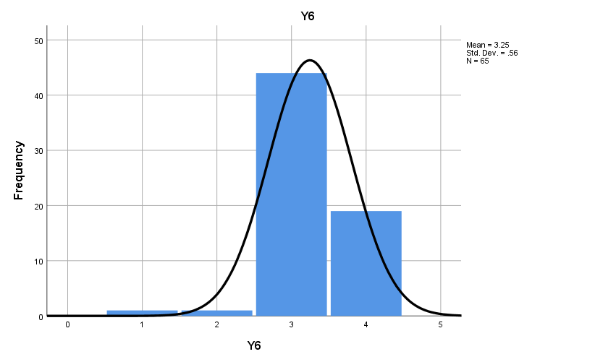

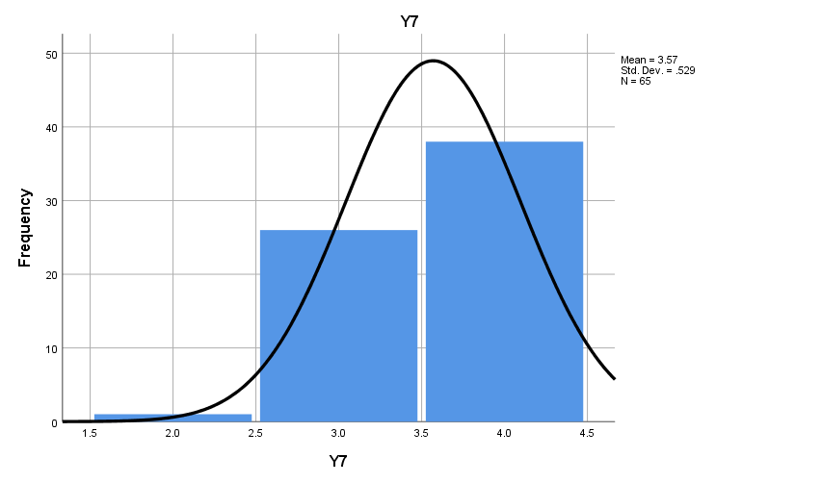

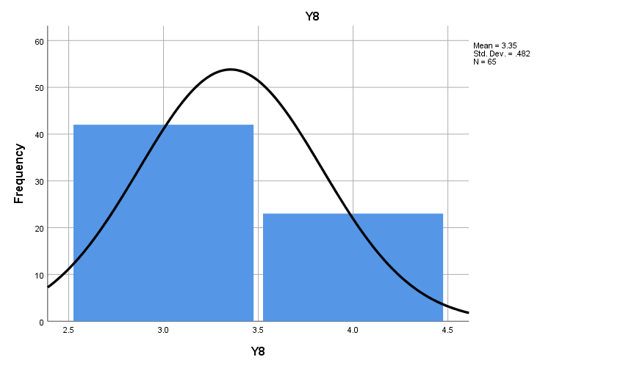

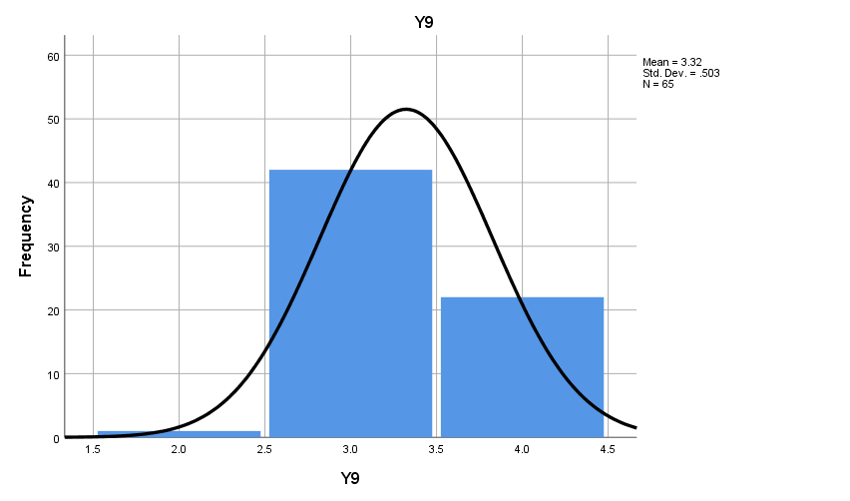

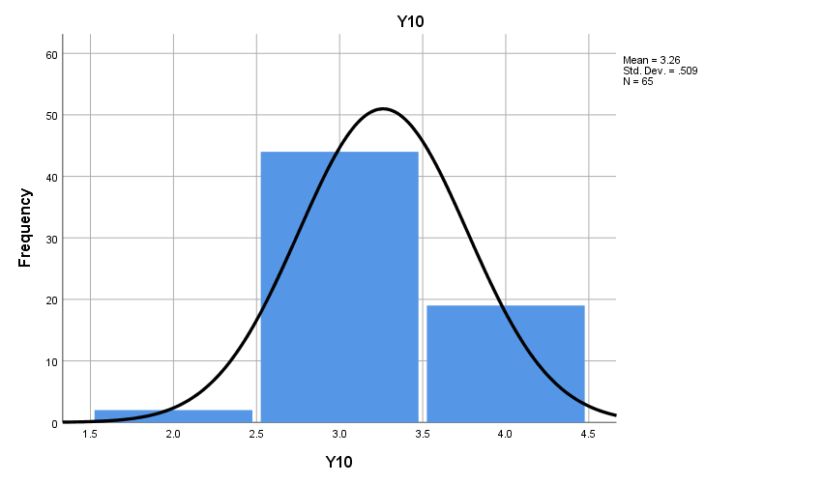

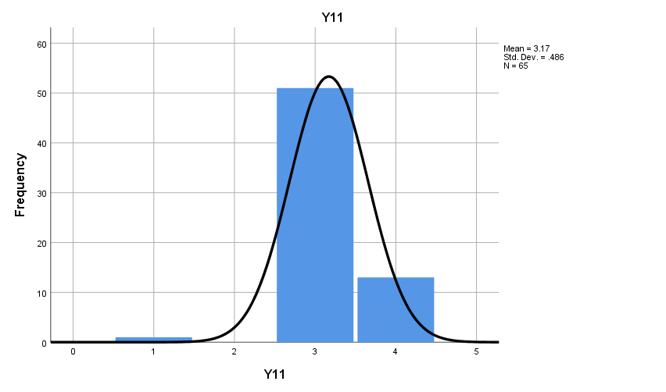

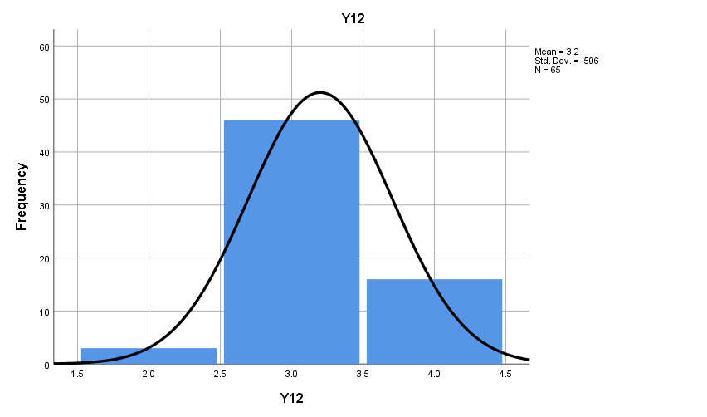

FREQUENCIES VARIABLES=Total_X Total_Y
/HISTOGRAM
/ORDER=ANALYSIS.

Frequencies

Notes
Output Created |  | 10-APR-2020 17:53:39
Comments
Input | Active Dataset | DataSet0
Input | Filter | <none>
Input | Weight | <none>
Input | Split File | <none>
Input | N of Rows in Working Data File | 65
Missing Value Handling | Definition of Missing | User-defined missing values are treated as missing.
Missing Value Handling | Cases Used | Statistics are based on all cases with valid data.
Syntax |  | FREQUENCIES VARIABLES=Total_X Total_Y  /HISTOGRAM  /ORDER=ANALYSIS.
Resources | Processor Time | 00:00:01,73
Resources | Elapsed Time | 00:00:01,37

Statistics
 |  | Total_X | Total_Y
N | Valid | 65 | 65
N | Missing | 0 | 0

Frequency Table

Total_X
 |  | Frequency | Percent | Valid Percent | Cumulative Percent
Valid | 49 | 1 | 1.5 | 1.5 | 1.5
Valid | 50 | 1 | 1.5 | 1.5 | 3.1
Valid | 51 | 14 | 21.5 | 21.5 | 24.6
Valid | 52 | 3 | 4.6 | 4.6 | 29.2
Valid | 53 | 6 | 9.2 | 9.2 | 38.5
Valid | 54 | 2 | 3.1 | 3.1 | 41.5
Valid | 55 | 2 | 3.1 | 3.1 | 44.6
Valid | 56 | 2 | 3.1 | 3.1 | 47.7
Valid | 57 | 1 | 1.5 | 1.5 | 49.2
Valid | 58 | 2 | 3.1 | 3.1 | 52.3
Valid | 59 | 5 | 7.7 | 7.7 | 60.0
Valid | 61 | 1 | 1.5 | 1.5 | 61.5
Valid | 62 | 1 | 1.5 | 1.5 | 63.1
Valid | 63 | 1 | 1.5 | 1.5 | 64.6
Valid | 64 | 5 | 7.7 | 7.7 | 72.3
Valid | 65 | 1 | 1.5 | 1.5 | 73.8
Valid | 66 | 1 | 1.5 | 1.5 | 75.4
Valid | 67 | 4 | 6.2 | 6.2 | 81.5
Valid | 68 | 12 | 18.5 | 18.5 | 100.0
Valid | Total | 65 | 100.0 | 100.0

Total_Y
 |  | Frequency | Percent | Valid Percent | Cumulative Percent
Valid | 27 | 1 | 1.5 | 1.5 | 1.5
Valid | 30 | 1 | 1.5 | 1.5 | 3.1
Valid | 33 | 1 | 1.5 | 1.5 | 4.6
Valid | 36 | 11 | 16.9 | 16.9 | 21.5
Valid | 37 | 7 | 10.8 | 10.8 | 32.3
Valid | 38 | 7 | 10.8 | 10.8 | 43.1
Valid | 39 | 6 | 9.2 | 9.2 | 52.3
Valid | 40 | 6 | 9.2 | 9.2 | 61.5
Valid | 41 | 4 | 6.2 | 6.2 | 67.7
Valid | 42 | 6 | 9.2 | 9.2 | 76.9
Valid | 43 | 5 | 7.7 | 7.7 | 84.6
Valid | 44 | 2 | 3.1 | 3.1 | 87.7
Valid | 45 | 1 | 1.5 | 1.5 | 89.2
Valid | 46 | 1 | 1.5 | 1.5 | 90.8
Valid | 47 | 2 | 3.1 | 3.1 | 93.8
Valid | 48 | 4 | 6.2 | 6.2 | 100.0
Valid | Total | 65 | 100.0 | 100.0

Histogram

CORRELATIONS
/VARIABLES=Total_X Total_Y
/PRINT=TWOTAIL NOSIG
/MISSING=PAIRWISE.

Correlations

Notes
Output Created |  | 10-APR-2020 18:08:58
Comments
Input | Active Dataset | DataSet0
Input | Filter | <none>
Input | Weight | <none>
Input | Split File | <none>
Input | N of Rows in Working Data File | 65
Missing Value Handling | Definition of Missing | User-defined missing values are treated as missing.
Missing Value Handling | Cases Used | Statistics for each pair of variables are based on all the cases with valid data for that pair.
Syntax |  | CORRELATIONS  /VARIABLES=Total_X Total_Y  /PRINT=TWOTAIL NOSIG  /MISSING=PAIRWISE.
Resources | Processor Time | 00:00:00,00
Resources | Elapsed Time | 00:00:00,14

Correlations
 |  | Total_X | Total_Y
Total_X | Pearson Correlation | 1 | .747**
Total_X | Sig. (2-tailed) |  | .000
Total_X | N | 65 | 65
Total_Y | Pearson Correlation | .747** | 1
Total_Y | Sig. (2-tailed) | .000
Total_Y | N | 65 | 65
**. Correlation is significant at the 0.01 level (2-tailed).

Correlations

Notes
Output Created |  | 10-APR-2020 18:27:39
Comments
Input | Active Dataset | DataSet1
Input | Filter | <none>
Input | Weight | <none>
Input | Split File | <none>
Input | N of Rows in Working Data File | 65
Missing Value Handling | Definition of Missing | User-defined missing values are treated as missing.
Missing Value Handling | Cases Used | Statistics for each pair of variables are based on all the cases with valid data for that pair.
Syntax |  | CORRELATIONS  /VARIABLES=X Y  /PRINT=TWOTAIL NOSIG  /MISSING=PAIRWISE.
Resources | Processor Time | 00:00:00,02
Resources | Elapsed Time | 00:00:00,05

[DataSet1]

Correlations
 |  | Persepsi Mahasiswa | Pelaksanaan PPG
Persepsi Mahasiswa | Pearson Correlation | 1 | .747**
Persepsi Mahasiswa | Sig. (2-tailed) |  | .000
Persepsi Mahasiswa | N | 65 | 65
Pengembangan Media Pembelajaran | Pearson Correlation | .747** | 1
Pengembangan Media Pembelajaran | Sig. (2-tailed) | .000
Pengembangan Media Pembelajaran | N | 65 | 65
**. Correlation is significant at the 0.01 level (2-tailed).

